Setup guide for Python Web Dev 28/03/2019

# Install Python

To check which Python version is installed on your machine, open the terminal and type:

python --version

If Python is NOT installed OR the Python version is less than 3.5 then you must install 3.7.2

* <https://realpython.com/installing-python/> will show you all the steps you need to follow to install Python for your operating system. (NB: You only have to follow the steps for the operating system that is on your machine)

# Create a virtual environment

A *virtual environment* is a semi-isolated Python environment that allows packages to be installed for use by a particular application, rather than being installed system wide.

venv is the standard tool for creating virtual environments, and has been part of Python since Python 3.3. Starting with Python 3.4, it defaults to installing pip into all created virtual environments.

Virtual environment **creation** on Linux systems:

$ python3 -m venv /myEnv

Virtual environment creation on Windows systems:

c:\>python -m venv c:\myEnv

To **activate** the virtual environment you created above use the appropriate command for your operating system:

**Please REMEMBER the path to your virtual environment.**

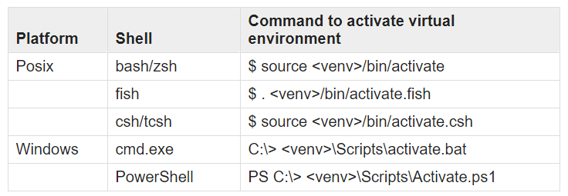

NB: <venv> in the table above is the path you specified during the creation of your virtual environment.

*To deactivate the virtual environment replace the word activate in the commands in the table above with the word deactivate. (e.g. $ source /myEnv/bin/deactivate)*

# Install Django, Django REST, Pillow and Coverage in your activated virtual environment

**With your virtual environment activated,** enter the following commands into your terminal

python -m pip install --upgrade pip setuptools wheel

pip install Django

pip install djangorestframework

pip install Pillow

pip install coverage

# Install Postman on your machine

The installer (Windows,MacOS and Linux) can be found here <https://www.getpostman.com/downloads/>

Here is a simple and straight forward guide to installing the app. <https://www.softwaretestingmaterial.com/install-postman/>

# Install Adobe Acrobat Reader

You **MUST** install adobe acrobat reader from <https://get.adobe.com/reader/> to be able to access and use the supporting materials for the workshop.

# Install Visual Studio Code

The recommended source-code editor is Visual Studio Code which you can download and install from <https://code.visualstudio.com/> .

Add the **Python Extension** to your Visual Studio Code to enable code formatting and linting. The extension can be installed from <https://marketplace.visualstudio.com/items?itemName=ms-python.python>

If you want to learn more about other extensions of VS Code you can read the following article <https://code.visualstudio.com/docs/editor/extension-gallery>